ENZYMES REVISION

# Question 32 (10 marks)

Parts (a) and (b) of the following question refer to the diagram below.

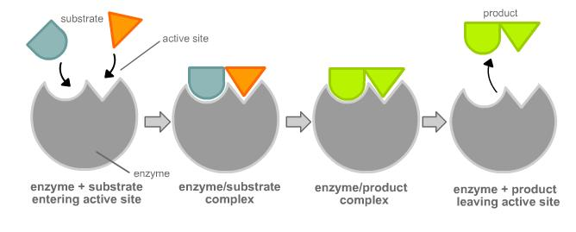

C

ABC

A

B

The diagram is a representation of the model called the ‘lock and key’, which is used to help explain the way enzymes work.

1. Using the lock and key model, name the following molecules.(3 marks)

B:

A and C:

A B C:

1. On the diagram above, draw a circle around the active site. (1 mark)

Parts (c) and (d) of the question refer to the information and diagram below.

A student used an enzyme to combine two types of sugars. Shown below is a graph of the rate of reaction as temperature increases.

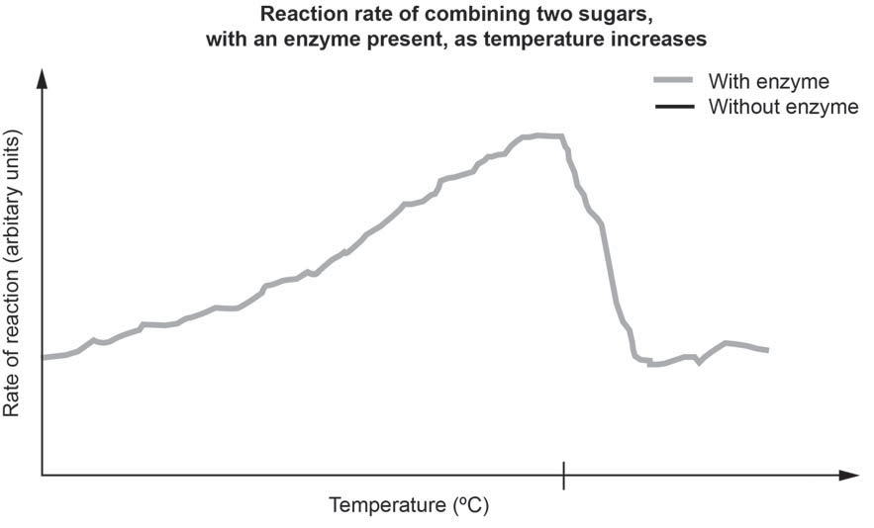

40

Complete the following questions, referring to the line on the graph.

1. Describe the rate of reaction as temperature increases. (3 marks)

Before 40 ºC:

At 40 ºC:

After 40 ºC:

1. Complete the following sentences relating to the reaction shown in the graph. (3 marks)

The activation energy of a reaction is the energy required to

a chemical reaction. The rate of the reaction up until 40 ºC has been altered by the presence of an enzyme. The enzyme has worked to

the activation energy of the reaction. After 40 ºC the reaction rate has changed

because the heat has caused the to change shape